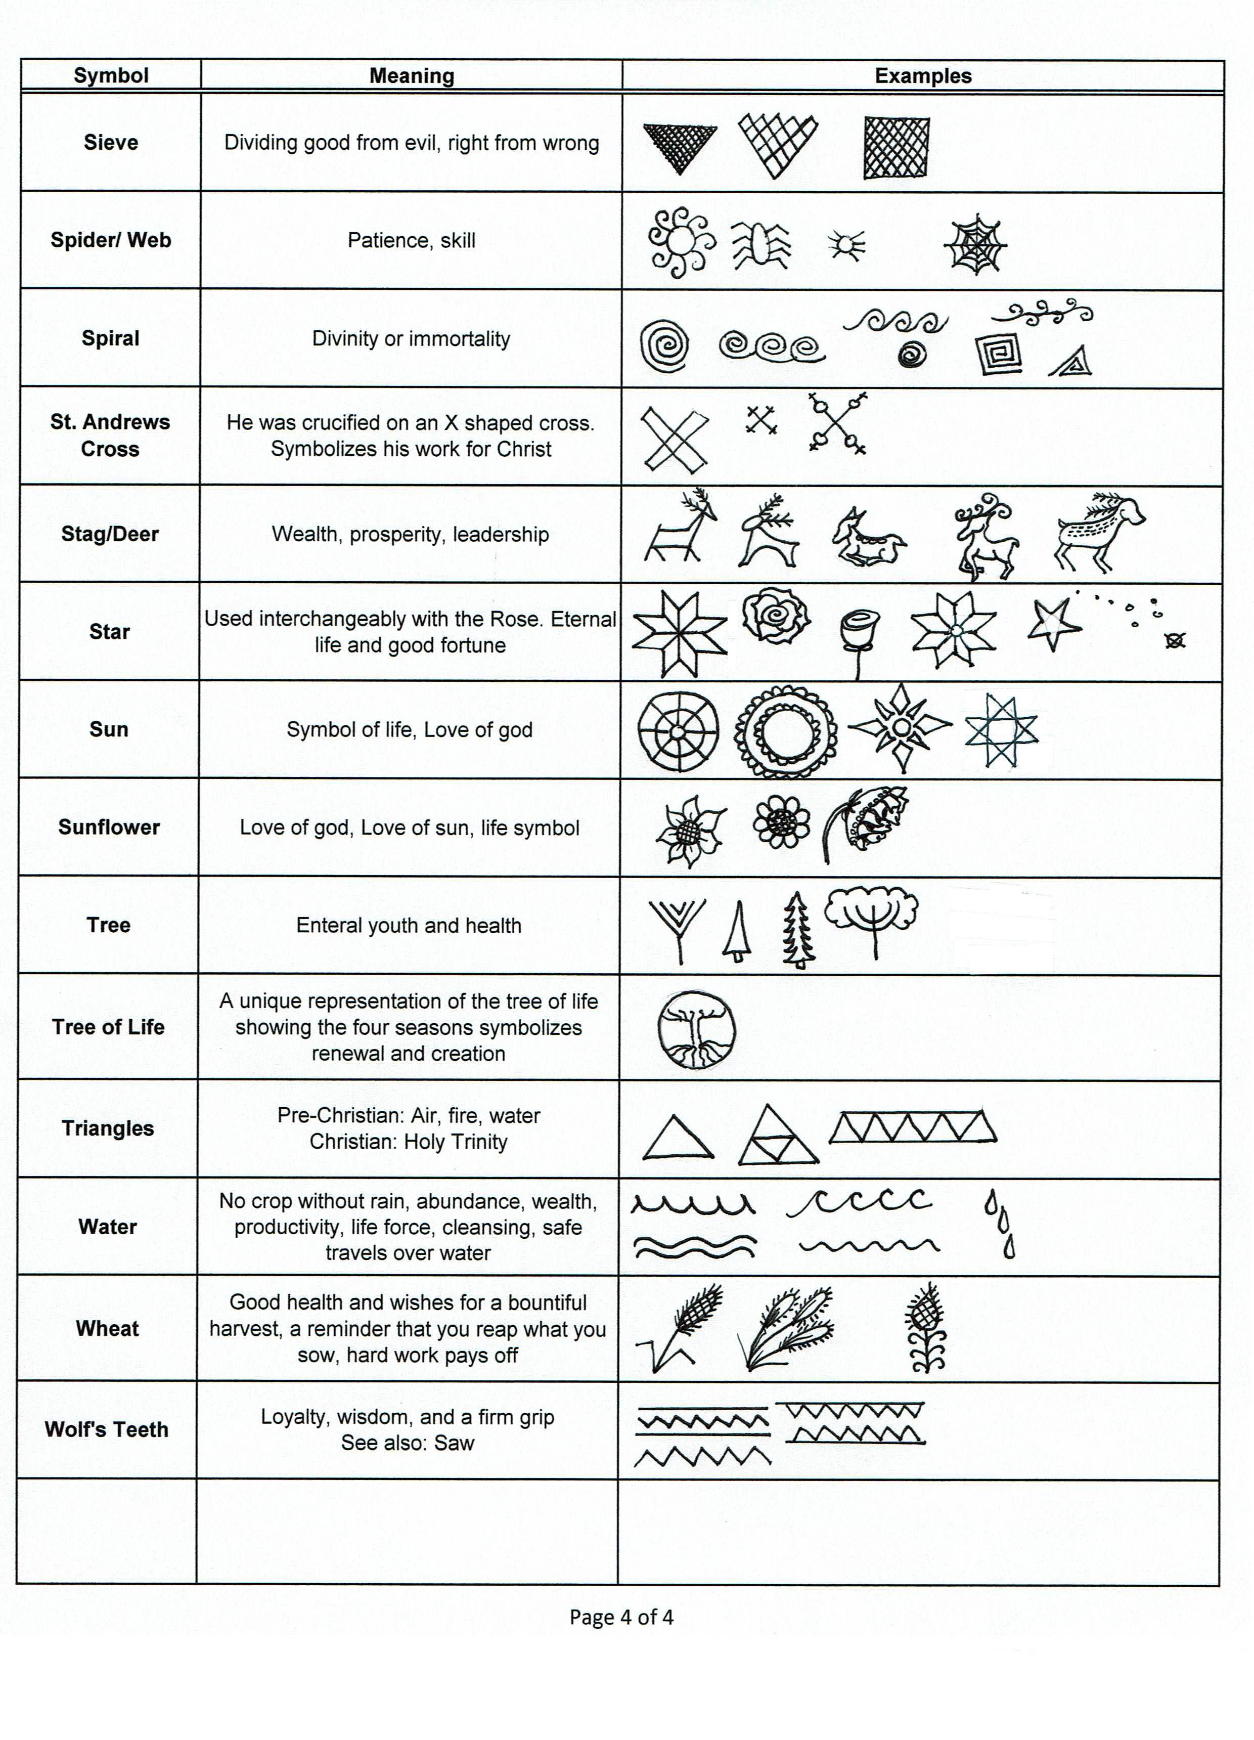
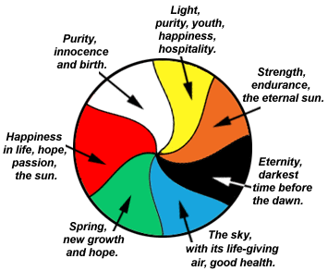

 |  |  |  | 
Ladders  prosperity, or prayer. | Pine Needles  health, stamina, eternal youth. | Crosses  Christ, or the Four Corners of the World. | Wheat  wishes for good health and a good harvest. | The Sun and Stars  life, fortune, growth.
 |  |  |  | 
Deer, Horses,and/or Rams  wealth and prosperity. | Fish  Christianity | Curls  defense or protection. | Roses  love, caring. | Poppies  beloved Ukrainian art motif, symbolizing joy and beauty.
 |  |  |  | 
Triangles  trinities, eg.: air, fire, & water; the Father, Son, & Holy Spirit; heaven, earth, & hell. | The Saw  fire, life-giving heat (also known as Wolves' teeth, symbolizing loyalty and wisdom). | Birds  fulfillment of wishes, and fertility. The bird is always shown at rest, never flying. | Nets  Christ's reference to becoming "fishers of people". | Ribbons  everlasting life, and water.

Notes:

Supplier Suggestions:
http://www.ukrainiangiftshop.com/
http://www.pysankyusa.com/shop2/
https://www.bestpysanky.com/pages/egg-decorating

References: https://www.marthastewart.com/270177/ukrainian-easter-eggs
https://www.instructables.com/id/Pysanky-Ukrainian-Egg-Dying/ https://www.pysanky.info/Dyeing/Dyeing_Home.html
http://www.pysanky.info/Natural_Dyes/Natural_Dyes.html
https://www.pysanky.info/Types/Types_Home.html
http://www.learnpysanky.com/steps.html
https://en.wikipedia.org/wiki/Pysanka
https://www.dhsparish.com/Pysanky.html
https://www.britannica.com/topic/Trypillya-culture
Rechenka's eggs by Patricia Polacco
1st Egg- White + 1 Color (Yellow, Red, Blue or Black)
2nd Egg- White + 2 Colors (Yellow, Red, Blue or Black)
Dye Order:
White –> Yellow –> Light Green –> Light Blue –> Orange –> Scarlet/Bright Red –> Final Color (Black)

2. Front/Back
2. Side/Profile
- Front/Back
- Side/Profile

